Narragansett Council Wide
Championship Klondike Derby
& Chili Bake

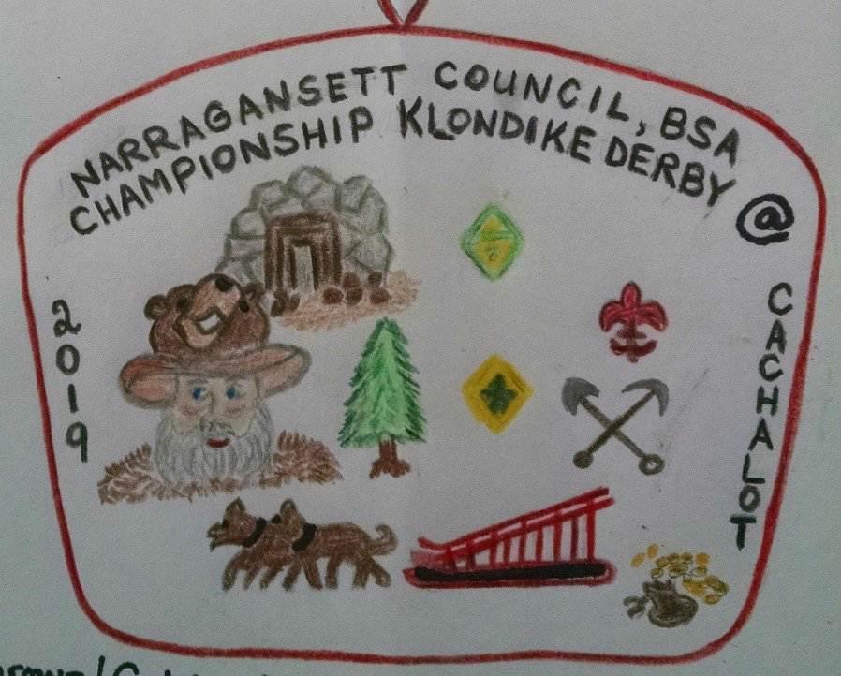

The top 6 qualifiers from:

Aquapaug, Buck Hill, Cachalot, Champlin, & Yawgoog 2019 Klondike Derbies

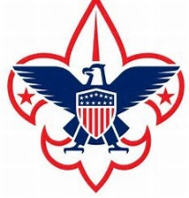
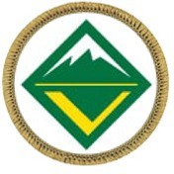
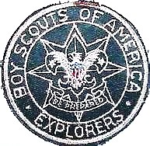
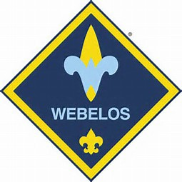

Webelos Scout Troops Venture Crews Sea Scouts Explorer Post

General Information

A. What is a Klondike Derby?

A Klondike derby is a one-day competitive event which uses sledges and Klondike Gold Rush themes to complete a multiple “Town” course and sledge race, pitting each team’s skills and team work against the clock. The purposes of the derby are: first a grand outdoor winter adventure full of fun and surprises, and second, a way for Scouts to test their basic camping and survival skills.

Only in case of extreme bad weather will the derby be postponed or cancelled.

Each Webelos Den/Scouts BSA Troop/Venture Crew/Sea Scout and Explorer is encouraged to enter as many expedition teams as they can support. The minimum team size is 4 Scouts; smaller teams will be combined so that all may participate. Maximum team size is 7 Scouts. Each expedition will visit several “Towns”.

The order of the towns must be followed using the map provided.

Each of these towns will have a Mayor and a minimum of two judges. The Mayor of the town can be identified by his orange “Mayor” stocking hat. The Scouts will have a task to complete and will be scored on proper technique, team work, and Scout spirit.

The Mayor’s word on all matters is final.

The Patrol Leader is the only member of the team that may communicate with the Mayor or Judges of the town.

THIS EVENT IS FOR SCOUTS ONLY

Each winning sledge (not including the Great Race Finalist) from all council wide Klondike’s must include the same Scout. If a Scout is a absent from your sledge, that sledge will have to run one person short. Troops are NOT ALLOWED to swap around or add a new Scout to their sledge.

ADULTS CAN NOT ASSIST THE PATROLS AND WILL NOT BE ALLOWED IN THE TOWNS. A MAYOR OF A TOWN WILL BE ALLOWED TO DEDUCT (25) NUGGETS AS A PENALTY IF THEY SEE ADULTS INTERFERING.

Have your Scouts refrain from bringing cell phones or other electronic devices to the Klondike Derby.

Inspection and Weigh-in Procedures

Each patrol will begin with a sledge inspection and weigh-in at The Outfitters (Boat House) field beginning at 6:45 AM until 8:30 AM. All sledges will be checked to insure all weight and dimension requirements are met and all equipment is present. Wheels are not allowed on the sledge.

The team will also be checked for proper dress for the day’s activities and the current expected weather conditions.

If the Klondike committee feels a Scout is not dressed properly for the conditions he will not be allowed to compete. In this case a team will be allowed to compete with three members.

EACH SCOUT MUST HAVE:

  - A stocking hat or hat with ear protection. (Baseball cap style hats will be allowed if the temperature is above freezing).
  - Gloves or mittens with hand warmers.
  - Proper footwear for conditions. Absolutely no sneakers allowed during the day’s activities.
  - A complete change of clothes.
  - Rain Gear (must be a jacket or poncho).
  - Totin’ Chip, Firem’n Chit.
  - One Compass and one Pace Counter for each team member

Any team meeting all of the requirements at this station will be awarded a bonus of 15 nuggets. If a patrol does not meet the requirements, they will be penalized at the end of the day’s activities with a deduction of (15) nuggets.

Empty sledges will be weighed and must weigh a minimum of 50lbs.

One bonus nugget will be subtracted for every 5 lbs. under weight. A team with an underweight sledge must add weight to bring the sledge’s weight to 50 lbs. A note will be added to the score sheet of such and Town Mayors will check that the weight is in the sledge. At any time during the day a staff or committee member can check sledges for proper equipment.

Check In

After weigh-in at The Outfitters (Boat House) Field, patrols will then proceed to Dawson City (The 21 Club). Only the Patrol Leaders’ are allowed to enter and register their patrol. He must bring a nugget pouch, waterproof map holder, Klondike Derby Sledge Registration forms are completely filled out (each sledge is to have their own registration sheet) and signed by the Scoutmaster. Please be sure you have written your Service Area in the appropriate place. Teams whose average age is 14 or more will compete in the Senior Division. Teams with an average age of 13.9 or younger will complete in the Scout Division.

Each Patrol Leader will be issued any last-minute instructions, an official map, and a score sheet. If your team makes no effort to do the compass course and Kims

Games, you will be given a zero for those events.

By participating in the Compass Course and Kims Games by all divisions, the points awarded from these events can make a difference in the final scoring.

After check-in, each patrol will proceed to the Yukon Territory (Tom Cullen Field) to park their sledge and the Patrol leader with an assistant is to walk over to the Bob Lecomete Pavilion to check in their menu and duty roster. Each sledge will be assigned their cooking station. Patrol Leaders also has to inform the Mayor on what time their planning to start preparing and cooking their lunch. After this is all completed, they are to return to their sledge to receive their assigned starting time. At 5-minutes intervals, the starter will send off 10 patrols into the vast tundra in search of Klondike Gold. Each team MUST follow the map issued at registration. Since Klondike is not a timed finished race, if anyone asked where a station is, please help your fellow Scout by giving them directions.

If a team arrives at a town out of order, they will receive ½ the nuggets they would have received had they arrived in the proper order. They will be instructed to go to the proper town and complete the task at that town before being able to continue.

There will be a CLAIM ROBBER in the mist of the Klondike Sledges asking participants questions through the event. Correct answers receive GOLD, Incorrect answered will lose GOLD.

Upon the completion of the last town of the day, the Patrol Leader and a buddy must report to the official scoring station at Dawson City (The 21 Club) with their score sheet and nugget pouch.

Only the Patrol Leader and the SM will be allowed in the scoring area. Once the Patrol Leader submits the score sheet, he/she will rejoin the patrol for the Great Race at the Trading Post.

Awards

Trophy and plaques will be awarded to the first-place teams in the Scout Division, Senior Division and WEBELOS Division

Plaques will be awarded to the second & third place finishers in each division and they will be awarded directly following the Great Race in the Dining Hall.

Equipment to be carried on the sledge

  - Patrol Leader arm band (Must have “PL” on it).
  - Nugget Pouch.
  - Notebook or clipboard & method to keep score sheet dry & neat.
  - Rain Gear for each team member (must be a jacket or poncho).
  - One (6ft) length 1/4 diameter rope per Scout.
      - Senior/Venturer/Sea Scout/Explorer will need 8pc.of rope, 6ft. minimum per sledge.
  - Hard hat, or bicycle helmet for each Scout.
  - One compass and one pace counter for each team member.
  - One hot cup for each team member.
  - Personal Cooking kit & utensils for each Scout.
- Senior/Venturer/Sea Scout/Explorer will need 8pc.of rope, 6ft. minimum per sledge.
  - Walking stick (Stave) for each Scout.
jj. Senior/Venturer/Crew/Post will need 6pc. of staves, minimum 6ft long.
  - One complete change of clothes for each team member.
  - (2) Unopened packaged hand warmers per Scout.
  - 1 Sleeping Bag.
  - Patrol Flag.
  - One Scout /Webelos Scout handbook per team.
  - Flint and steel.
  - One (20ft) length of ¼ diameter rope.
  - One steel trash can cover or similar to put hot coals in for cooking lunch.
  - First aid kit (must contain recommended equipment for Patrol/Webelos Den/Scout Troop/Venture Crew/Sea Scout/Explorer from Scouting hand book page.)
  - Two warm blankets.
  - Roll of toilet paper.
  - Two clean (NO PAINT OR OIL) #10 can with wire handle.
  - Dish soap, and sponge.
  - Oven mitts or cooking gloves.
  - Trash bag for rubbish.
  - Dishwash tubs.

Scoutmasters Notes

Scoutmasters or their representative should make every attempt to attend the Klondike Derby pre-meeting. This is where information is shared, and any questions or concerns are answered.

Each unit participating will provide a minimum
of two adults to man the Klondike towns in order to have a successful day.

Mayors must check in with the Governor at Dawson City (The 21 Club) before going to your town. All stations must be manned by 6:30AM.

Official Klondike Derby Regulations

The following regulations are in place to ensure a safe and enjoyable event. Please follow directions, and respect other individuals competing in the days’ events.

- All walking sticks are for walking and to be used as tools where they will be needed. They may be stored on the sledges until they are needed, or a Scout may use them to assist in walking the course throughout the day. Patrols or Scouts caught swinging sticks, WILL LOSE 25 nuggets and a warning will be issued. In the event a second warning is issued the patrol will be dismissed from the event.

- Each Webelos Den/Scout Troop/Venture Crew/Sea Scout/Explorer is required to have at least two adults serve on the Klondike staff in some capacity (Mayor, Scorer, Judge, etc.)

- Each patrol must have the same winning members of their previous Klondike. There is NO SUBSTITUTION or STACKING OF THE SLEDGE. (The exception to this rule is when a team loses a team member due to a Scout not being dressed properly. (See section 1B par. 2 above)

- Each Scout must be dressed appropriately for the days’ weather conditions.

- Each unit must submit a roster for each team signed in by the Patrol Leader at the time of check-in.
- Each Team must turn in a copy of their menu for lunch to the Mayor @ Bob Lecomete Pavilion.
- NO TEAM will be allowed to begin before 8:00AM or after 12:00PM, From Dawson City (21 Club) sledges are to gather in Yukon Territory (Tom Cullen Field) and a sound will signal from Yukon Territory (Tom Cullen Field), an
adult will announce when to start!
- Adults will not be allowed to physically help, aid verbally, or assist in anyway, with any team during the days’ events including lunch. WEBELOS Leaders and/or Den Chiefs may assist a WEBELOS Sledge at the Valley Forge cooking station.
- Any injured or ill Scout or Scouter must present himself to the Klondike medical staff located at the Handicraft Post.
- The registration fee for each Scout and Scouter will be posted on the Narragansett Council Website. A Scout dismissed because of behavior and or lack of proper clothing will not be entitled to any refund.

- Each patrol leader must wear an arm band displaying the letters “PL”

- Five-Mile pond and all other bodies of water are entirely off limits to everyone in camp, including staff and unit leaders. This rule is in effect whether the ponds are frozen or not. This includes throwing rocks, sticks or other objects. Any team or individual not in compliance may

be disqualified.

- Sledge Inspection
  - Each sledge must be six feet long.

  - Each sledge must display a patrol flag.

- Each sledge must weigh 50lbs when empty. Nuggets will be deducted for underweight sledges and weight must be added to come up to the 50lbs.
Any weight added must be secured and remain on the sledge until the completion of the great race. NO TIRES ARE ALLOW ON ANY SLEDGE FOR THIS EVENT!!

Mayors, Judges, Scorers, or Committee Members may deduct up to ½ the nuggets earned at that Town

Special Notes, Reminders & Changes

Please note that any station outlined below may be changed without notice due to staffing requirements.

PER THE CAMP RANGER; only above ground fires will be allowed. All fires in towns without a fire pit shall be in a half barrel. Let the fire burn itself out, do not put the fire out. Make sure the fire has burned down before leaving. Leave the ashes in the half barrel and do not empty the ashes in the site or in the woods. The Ranger will empty and properly dispose of the ashes in the barrels or containers.

Some picnic tables will be available. If you move a table, please return it to its original location when done.

ABSOLUTELY NO VEHICLES OR TRAILERS WILL BE ALLOWED TO STAY IN THE KLONDIKE ACTIVITY AREA. ALL VEHICLES AND TRAILERS MUST BE RETURNED TO THE PARKING AREA BY 6:45 AM.

KLONDIKE PARKING STAFF WILL DIRECT YOU WHERE TO PARK. UNITS WITH TRAILERS WILL ALSO BE DIRECTED WHERE TO PARK

No M.R.E’S will be allowed for the Cooking Town. Judging for lunch will be based on preparation, organization, cooking skills, clean up and the percentage of Scouts with Firem’n Chit or Outdoorsman badge. Adult leaders and parents that are accompanying the sledge are to provide their only lunch. This meal is for the youth Scouts on the sledges only.

During lunch only one town will remain active, that town will be Valley Forge. Any mayor and staff member not helping at Valley Forge can eat a hot lunch; have a warm drink or just warm up at Dawson City (The 21 Club).

Schedule of Events

6:45-8:30 Weigh-in & Sledge inspection at The Outfitters (Boat House)
7:00-8:30 Registration at Dawson City (The 21 Club) 7:00-8:45 Turn in Menu to the Mayor @ Bob Lecomete
Pavilion which is attatched to Noquochoke Lodge.

8:00 am Patrols started at Yukon Territory (Tom Cullen Field)

8:00-12:00 Klondike Underway

12:00-1:00 Lunch (1hour)

1:00-4:00 Klondike Underway

4:15-4:45 Great Race @ Trading Post to Run UP Dinning Hall Hill

5:00pm on AWARD Ceremony @ Dining Hall

Cheechaku – Blind Tent Set-Up

Location – Scoutcraft Area (Field left of Noquochoke Lodge)

Task: There’s a major storm coming that is going to blind everyone but one person on your sledge. That one person will be in a sleeping bag telling the other blinded Scouts how to setup the tent.

**Senior/Venturer/Sea Scout/Explorer Division**
They will have to walk blinded through a maze by the Patrol Leader directions to arrive at the tent location. Than complete the task for blind tent set-up.

Scoring: WEBELOS/Scouts
1. | Less than 3 Minutes | 10 nuggets
2. | 3 Minutes to 3:59 | 9 nuggets
3. | 4 Minutes to 4:59 | 8 nuggets
4. | 5 Minutes to 5:59 | 7 nuggets
5. | 6 Minutes to 6:59 | 6 nuggets
6. | 7 Minutes to 7:59 | 5 nuggets
7. | 8 Minutes to 8:59 | 4 nuggets
8. | 9 Minutes to 9:59 | 3 nuggets
9. | 10 Minutes to 10:59 | 2 nuggets
10. | 11 Minutes to 13 Minutes | 1 nugget

Scoring: Senior/Venture
1. | 3 Minutes to 3:59 | 10 nuggets
2. | 4 Minutes to 4:59 | 9 nuggets
3. | 5 Minutes to 5:59 | 8 nuggets
4. | 6 Minutes to 6:59 | 7 nuggets
5. | 7 Minutes to 7:59 | 6 nuggets
6. | 8 Minutes to 8:59 | 5 nuggets
7. | 9 Minutes to 9:59 | 4 nuggets
8. | 10 Minutes to 10:59 | 3 nuggets
9. | 11 Minutes to 13 Minutes | 2 nuggets
10. | 13 Minutes to 15 Minutes | 1 nugget

  - Attu – Mushing

Location – Gaga Pit in Tom Cullen Field

Task: Driving a Klondike sledge is called mushing and requires the Scout to work together as a coordinated team. The Patrol Leader is the musher, who will be in charge of the team. The musher is in the back helping the team push while using the commands below to direct the team. To give a command to the entire team, just say it. To give it to one person or a few people, say the name of the person followed by the command.

Command List:
- Hike: Start moving
- Haw: Turn left (“Haw, like southpaw”)
- Gee: Turn right (“Gee, that’s right”)
- Good: Keep doing what you’re doing.
- Easy: Slow down but keep moving. Don’t let the rope go slack.
- Pick it up: Go faster
- Gee Over: Move to the right side of the trail.
- Haw Over: Move to the left side of the trail.
- On By: Keep going straight
- Whoa: Stop

1. | Less than 1 Minute | 10 nuggets
2. | 1 Minute to 1:59 | 9 nuggets
3. | 2 Minutes to 2:59 | 8 nuggets
4. | 3 Minutes to 3:59 | 7 nuggets
5. | 4 Minutes to 4:59 | 6 nuggets
6. | 5 Minutes to 5:59 | 5 nuggets
7. | 6 Minutes to 6:59 | 4 nuggets
8. | 7 Minutes to 7:59 | 3 nuggets
9. | 8 Minutes to 8:59 | 2 nuggets

Dead Horse - First Aid

Location – Health Lodge

Task: In this town when you check-in with the mayor a scenario will be selected at random and your team will be required to demonstrate treating a person with an injury.

**Webelos/Scout Division**
Task: The questions & demonstration will come from the Webelos and Scout handbook and the Scout field book.

**Senior/Venturer/Sea Scout/Explorer Division**
Task: For your task at this station you will need to know 1 handed bowline, splint and bandages, you will be given your scenario when you arrive at this station. Splints and rags will be provided for your use.

All: Think about what steps you should take, and what sequence you should correctly follow.

You will be given 2 gold nuggets for each correct answer.
You will be given up to 12 gold nuggets if the sequences are correct. Be ready for bonus questions!

All these emergencies and first aid scenarios are written to make you think about treating various types of situations and injuries. At the same time not making things worse for the injured or for the Webelos Den/Scout Troop/Venture Crew/Sea Scouts/Explorer itself.

The plan is to treat the injuries and get the injured person the correct and best help as quickly as you can, or to avoid these types of problems in the future. The scenarios will be provided to the Patrol Leader at registration.

Total for correct answers Total for correct sequence Total points for first aid.

Fort Yukon – Rifle Competition

Location – Rifle Range

BB Competition -**WEBELOS** - Location: Archery Range
- Black Powder Rifle Competition – Location: Shotgun Range
**Senior/Venture/Ships/Explorers**
- 22 Rifle Competition -**Scout**- Location: Rifle Range

Task: Your patrol has just entered a rifle competition for bragging rights in the Yukon Territory (Tom Cullen Field). Using a 22 caliber for Scout Division and Black Powder for **Senior/Venturer/Sea Scout/Explorer Division** (BB guns for WEBELOS) each Scout will be given 5 shots at targets. Each target score will be added together and then divided by the number of shooters to arrive at an average score. WEBELOS will use BB Guns. Your sledge will have a total of 2 ½ minutes to make all 5 shots.

THERE IS A ZERO TOLERANCE POLICY FOR HORSEPLAY OF ANY KIND ON THE RANGE. ANYONE CAUGHT WILL BE ASKED TO LEAVE THE RANGE.

If a person is asked to leave, his score will not count, and the total number of shooters will not change.

Scoring:
1. | Score 1 - 10 | 1 nugget
2. | Score 11 - 20 | 2 nuggets
3. | Score 21 - 30 | 3 nuggets

Whitehorse – Log Pull by Pully System

Location – Blue Spruce Pine Grove (across from Noquochoke Lodge) Task: The storm has ended but trees have fallen blocking your trail. You will be
given a rope, a pully, a harness, and log rollers to help move the logs. NO ONE is allowed to touch the log with their hands and/or feet for the entire station. Each sledge with have 2 minutes to examine a pre-set log pully system. They need to use
the correct knot on the log(s), which is found in their Scout handbook. Pull the log for the specified distance marked and then each sledge is required to retrieve the log, dismantle the pully system, and coil up the rope correctly to complete the task.

Scoring:
1 | Under 4 Minutes | 10 Nuggets
2 | 4 Minutes to 4:59 | 9 Nuggets
3 | 5 Minutes to 5:59 | 8 Nuggets
4 | 6 Minutes to 6:59 | 7 Nuggets
5 | 7 Minutes to 7:59 | 6 Nuggets
6 | 8 Minutes to 8:59 | 5 Nuggets
7 | 9 Minutes to 9:59 | 4 Nuggets
8 | 10 Minutes to 10:59 | 3 Nuggets
9 | 11 Minutes to 11:59 | 2 Nuggets
10 | 12 Minutes | 1 Nuggets

Skagway - Wood Splitting

Location – Scoutcraft Area (Field left of Noquochoke Lodge) Prerequisite: Totin’ Chip/Whittling Chip will be required
Task: Scout division: At this station you will need to cut and split the provided wood in preparation for the Kodiak Station. You must use a bow saw to make 2 cuts and a hatchet to properly split the wood provided. A knife to whittle and make tinder. You will also need to show and demonstrate the proper use, storage, handling and sharpening of each tool. All Scouts working in the station are required to wear eye protection. Glasses and gloves will be provided if needed at this station.

**Senior/Venturer/Sea Scout/Explorer Division Only**

Task: Senior/Venturer/Sea Scout/Explorer Division: At this station you will need to cut and split the provided wood in preparation for the Kodiak Station. You must use a 2-man cross cut saw to make your cuts, a spitting maul to split your wood and a hatchet to split further. A knife to whittle and make tinder. You will also need to show and demonstrate the proper use, storage, handling and sharpening of each tool. All Scouts working in the station are required to wear eye protection. Glasses and gloves will be provided if needed at this station.

WEBELOS will be required to demonstrate pocket knife safety at the Kodiak - Fire Dowsing station. Webelos will not come to Skagway- Wood splitting.

50 minutes maximum time for this station

Objectives to be completed
1 | Produce Totin’ Chip/Whittling Chip | 1 nugget each
2 | PPE (eye protection/gloves) | 2 nuggets
3 | Knowledge and use of Bow saw | 7 nuggets
4 | Knowledge and use of Hatchet | 11 nuggets
5 | Knowledge and use of Knife | 5 nuggets

Senior Alternative Scoring

3 | Knowledge and use of 2 Man saw | 7 nuggets
4 | Knowledge and use of Splitting Maul | 11 nuggets

**Senior/Venturer/Sea Scout/Explorer Division Only**

AFTER YOU COMPLETE THIS STATION YOU MUST BRING YOUR SPLIT WOOD & SHAVINGS TO BE USE AT FIRE DOUSING

Kodiak - Fire Dousing

Location – Cadre (Behind Noquochoke Lodge)

Prerequisites: Fire’m Chit/Outdoorsman Badge & complete wood splitting at Skagway.

Task: At this town you will build a fire lay no higher than 12 inches. Light the fire without the use of matches. Burn through the upper mark, 24 inches, and melt bag, releasing water to extinguish the fire.
Flint and Steel only will be allowed. You will be timed from the first attempt to light the fire until the release of the water. You must tell the judge when you are ready to start; the judge will inform you when you may start. After starting the fire, you may not add fuel. You will be allowed to fan and/or shield your fire from the wind. Lint will be provided by the Mayor. Once the fire is lit for 2 minutes then the string will be strung, and the timing of the event will begin.

WEBELOS will be allowed to supply their own kindling and tinder for this event. Bare clean wood only!
Scouts – Bring the split wood & shavings from WOOD SPLITTING STATION THIS IS THE ONLY WOOD TO BE USED AT FIRE DOUSING
Scoring: One nugget will be awarded to each team member showing their Fire’m to
the Mayor upon entry to the town with asking. It will not be the responsibility of the mayor to ask for a Fire’m Chit from any team member not involved directly in the lighting of the fire.

50 minutes maximum time for this station

Webelos/Scout Division Scoring:

 | Fire is lit and burning for 2 minutes | 5 nuggets
 | Burn String in 7-10 minutes | +1 nuggets
 | Burn String in 6-6:59 minutes | +2 nuggets
 | Burn String in 5-5:59 minutes | +3 nuggets
 | Burn String in 4-4:59 minutes | +4 nuggets
 | Burn String in 3-3:59 minutes | +5 nuggets
 | Burn String in 2-2:59 minutes | +6 nuggets
 | Burn String in 1-1:59 minutes | +7 nuggets
 | Burn String in 39-59 seconds | +8 nuggets
 | Burn String in 19-58 seconds | +9 nuggets
 | Burn String in 0-18 minutes | +10 nuggets
 | Total

**Senior/Venturer/Sea Scout/Explorer Division Only**

Bring the split wood & shavings from WOOD SPLITTING STATION THIS IS THE ONLY WOOD TO BE USED AT FIRE DOUSING

Bow and String Fire Drill. You will be timed from the first attempt to light the fire until the release of the water. You must tell the judge when you are ready to start. Using bow and string fire drill starting kits will be at station if you don’t have your own. The nest material needed for your spark will be given to you by the mayor to make your nest. In this station, you can add your tinder as needed to build the flame in the first 2 minutes after adding nest. The fire must stay lit for 2 minutes minimum. You must use fire gloves to pick up the lit nest. You have the option to bring your own Bow Drill set or use the ones that will be provided at the station. Also, we will have Bow Drill Set for sale if you would like to practice.

50 minutes maximum time for this station

Scoring:
1. | 1-6 minutes | 10 nuggets
2. | 6-8 minutes | 9 nuggets
3. | 8-10 minutes | 8 nuggets
4. | 10-12 minutes | 7 nuggets
5. | 12-14 minutes | 6 nuggets

6 | 14-16 minutes | 5 nuggets
7. | 16-18 minutes | 4 nuggets
8. | 18-20 minutes | 3 nuggets
9. | 20-22 minutes | 2 nuggets
10. | 23-25 minutes | 1 nuggets

One nugget will be awarded for each team member who shows the Mayor their Fire’m chit. It will not be the responsibility of the mayor to ask for a Fire’m chit from any team member not involved directly in the lighting of the fire. There is no Venture’s Fire’m chit so to make it fair, they will be given 1 nugget per participant.

Satan’s Landing - Chasm Crossing

Location - Namasket

Task: Your patrol is proceeding down a trail in search of gold. You come across a bridge that has been washed out by a storm. The only things spanning the 100ft Chasm are 2 railroad planks laying side by side and 6 poles to use as rollers. Your problem is to get the entire patrol, along with your sledge and equipment, across safely without falling into the chasm. If a Scout falls or steps off the planks and his feet touch the ground, he is considered dead and cannot continue to help. If your sledge falls off, you must start again.

1. | Less than 1 Minute | 10 nuggets
2. | 1 Minute to 1:59 | 9 nuggets
3. | 2 Minutes to 2:59 | 8 nuggets
4. | 3 Minutes to 3:59 | 7 nuggets
5. | 4 Minutes to 4:59 | 6 nuggets
6. | 5 Minutes to 5:59 | 5 nuggets
7. | 6 Minutes to 6:59 | 4 nuggets
8. | 7 Minutes to 7:59 | 3 nuggets
9. | 8 Minutes to 8:59 | 2 nuggets

Sledges absolutely must use POLES to roll sledge across

bridge.

  - Sourdough - Knot Knowledge

Location - Mattapoisett

Task: Using the ropes available on your sledge, each team member must demonstrate your knowledge of knots from handbook, each knot identified, told what it is used for and tied correctly for a maximum of 3 nuggets per knot.

**Scout Division**
May be asked to demonstrate the Square Lashing, Diagonal Lashing or Share
Lashing which is found in their Scout Handbook

**Senior/Venturer/Sea Scout/Explorer Division**
May be asked to demonstrate the Filipino Lashing & Japanese Square Lashing (Input directions for these lashing but change the title to Knot Knowledge) The following knot must be demonstrated which can be found on the internet:
- Truckers Hitch
- Diamonds Hitch
- One Handed Bowline
- Pendant Hitch
- Lobster Buoy Hitch
- Dutch Marine Bowline
- Adjustable Hitch
- Constrictor Hitch

Knot | Lashing | Use | Tied Correctly | Total Points
 |  |  | TOTAL:

THESE LASHING WILL BE USED FOR SENIOR/VENTURER/SEA SCOUT/EXPLORER PATROLS AT SOURDOUGH – KNOT KNOWLEDGE

Filipino Lashing

This is an alternative to a diagonal lashing.
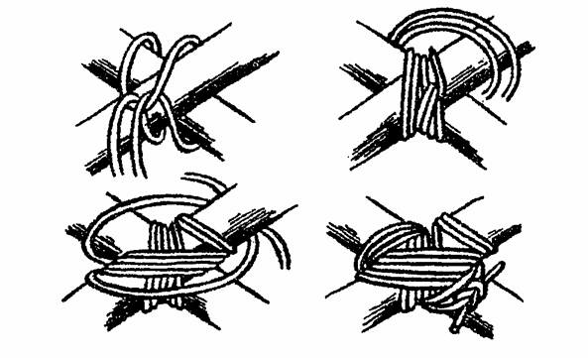

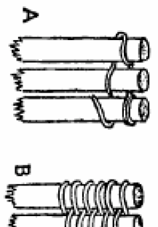

23
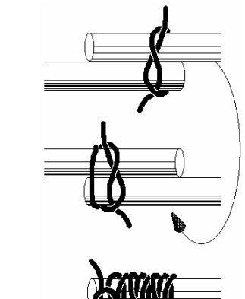

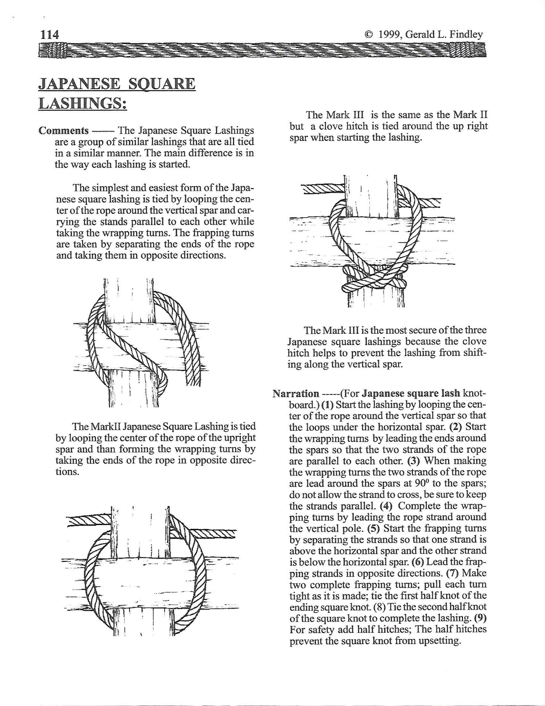

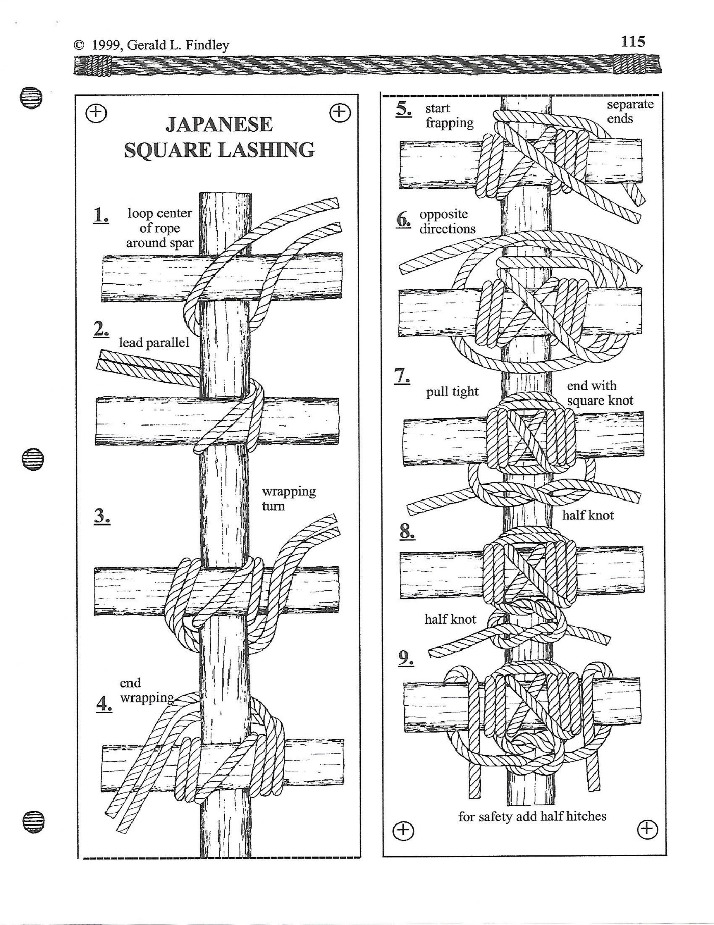

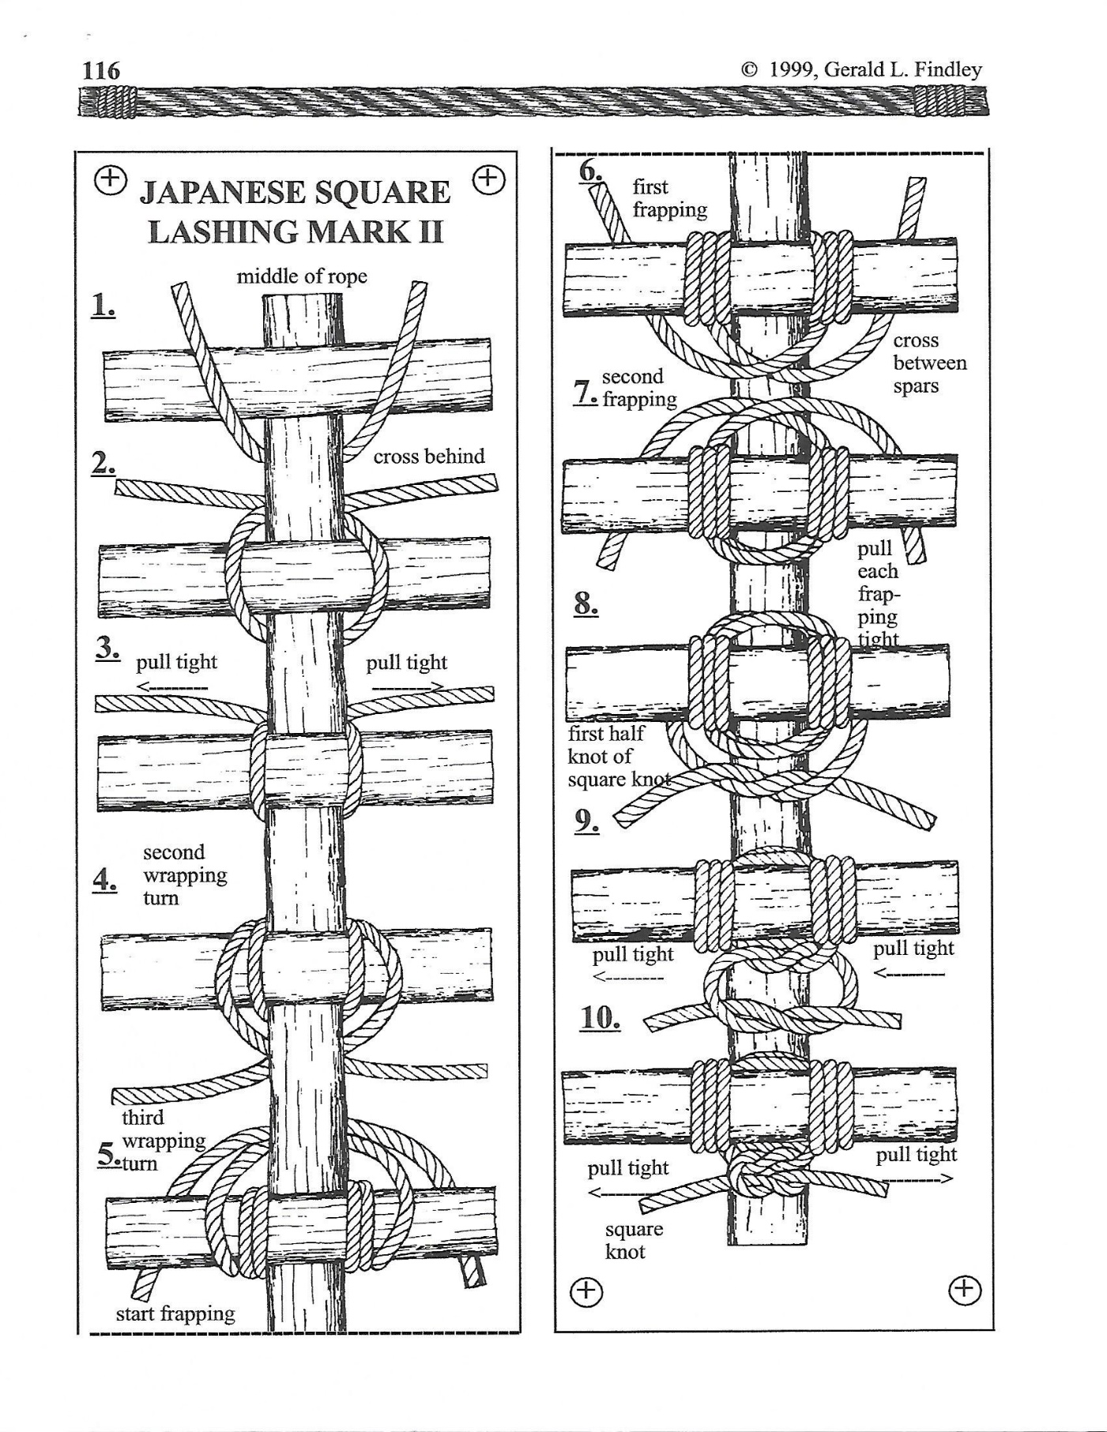

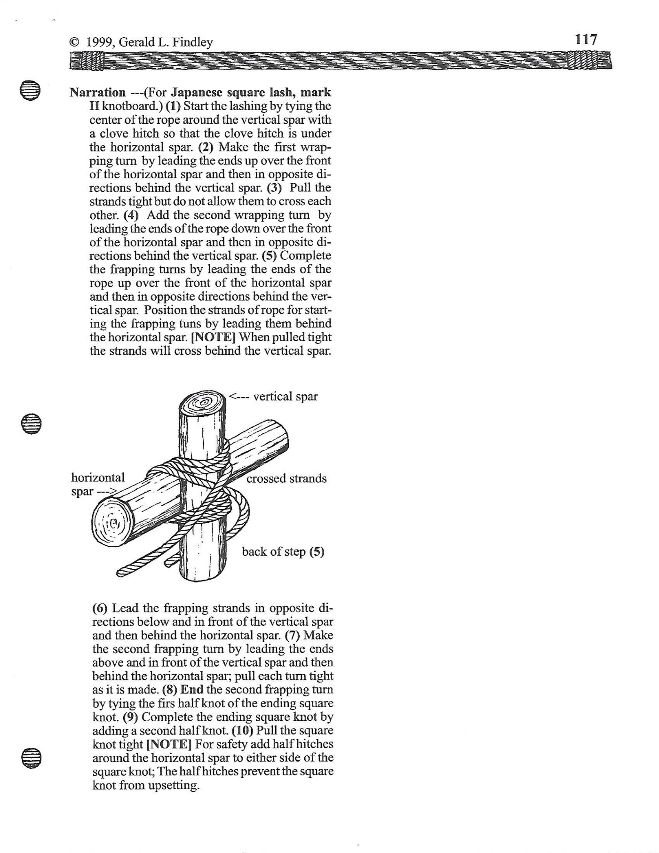

(A) Crooked Creek - Milk Box Stacking

**WEBELOS/Scout Division**

Location – Acooshnet

Task: Try your hand at stacking milk crates, the higher you stack the more gold you get. SCOUTS MAY USE ONLY ONE HAND, NO ROPES WILL BE USED IN STACKING THE CRATES, NO STANDING ON CRATES; ALL SCOUTS
MUST HAVE BOTH FEET ON THE GROUND. Scouts may use only one hand and all Scouts may participate. This will be a timed event; you have a total of (5) five minutes to complete your task. If a stack falls you may try again. Please note that the tallest stack will be the one that is scored, and you may stop at any time. All participants must wear a hard hat or bicycle helmet. Ask any questions before starting the event.

18 Crates High | 10 Nuggets
17 Crates High | 9 Nuggets
16 Crates High | 8 Nuggets
15 Crates High | 7 Nuggets
14 Crates high | 6 Nuggets
13 Crates High | 5 Nuggets
12 Crates High | 4 Nuggets
11 Crates High | 3 Nuggets
10 Crates High | 2 Nuggets
1-9 Crates High | 1 Nugget

10. (B) Rabbit Creek – Hatchet Throwing

**Senior/Venturer/Sea Scout/Explorer Division**

Location – Parade Field (across from Dinning Hall)

Prerequisite: Totin Chip for Senior Division a MUST. No Totin Chip for Ventures

Task: Take a chance at a Bulls-Eye. The time has come for competing amongst other teams fighting for gold nuggets in this Hatchet Throwing Contest at Rabbit Creek in Yukon Territory.

Points Value:
1. | The Bullseye or Black Ring | 8 nuggets
2. | The Red Ring | 4 nuggets
3. | The Blue Ring | 2 nuggets
4. | The Clutch Green Dot | 16 nuggets

Clutch:

- Players must declare that they are going to throw for Clutch before attempting, also referred to as 'Calling Clutch' or to 'Call Clutch';
- Players can only throw for Clutch on the 5th and final throw of the round;
- An accidental clutch is not valid, even on a 5th throw, no call, no points;
- Once Clutch is called, only that point area is valid, and all other point areas are worth zero:
  - Meaning that if a player calls for Clutch but hits a bullseye, they
receive no points.
- A Clutch call can be taken back after it is called but must be announced to their opponent and scorekeeper:
  - If a Clutch call is denounced the target reverts to its original values and the Clutch is worth zero

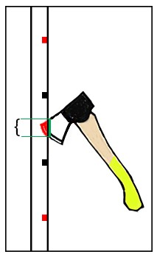
Target and Scoring Rings:

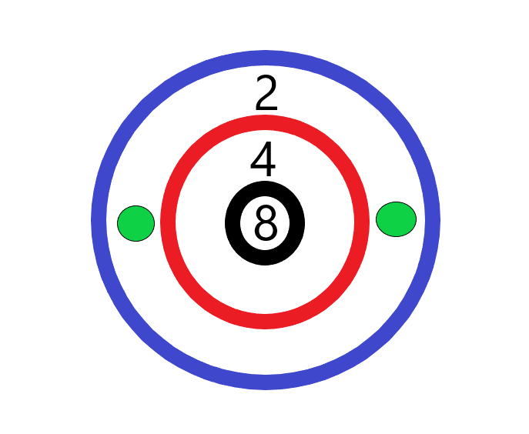

BONUS NUGGETS:
Additional Nuggets will be awarded for:
    - Naming the parts of the Axe/Hatchet.
    - Safe caring, Handling and storage of the Axe/Hatchet.
    - Displaying Totin Chit.

Valley Forge – Lunch – All Divisions
** Above Ground Chili Bake Off **
(NO CANNED / PRE-COOKED CHILI ALLOWED)

Location – Pine Grove

Task: You have been on the trail all morning; your team is starting to get tired & worn down from the hilly terrain and tough walking. You decided to break for lunch, park your sledge in Yukon Territory (Tom Cullen Field).

Directly after checking in, each sledge is to head to the Bob Lecomte Pavilion to turn in your chili menu with duty roster. After they’re accepted, your sledge will receive a number and a location on where you will be setting up. Each sledge will have to make sure you time your cooking correctly. Lunch is to be ready and served by noon time, which means, during the morning stations your patrol will determine when to head back to the cooking station to start. After the prep work is completed and chili is cooking, your patrol is to head back to your next station and return to the Klondike competition. At any time, you are allowed to check and stir your chili, then return back to you schedule. Charcoal will be provided.

THIS CHILI WILL BE YOUR LUNCH FOR THE EVENT! NO PARENTS OR LEADERS ARE ALLOWED TO EAT THE SCOUTS FOOD AT THIS STATION.

- Chil Koot Pass – Compass Course

Location: Yukon Territory (Tom Cullen Field)

Task: The compass course for all divisions will be handed out at registration. Everyone can earn (5) extra nuggets if they complete the course correctly. This must be turned in with your score sheet. (A CELL PHONE CANNOT BE USED AS YOUR COMPASS).

Kims Games

Location: Warming Station

Task: Do to a long trail your team is getting delirious for all the hard work at the stations. This brain challenge will help you sharpen your mind. Everyone can earn
(5) extra nuggets if they complete the course correctly.

The Great Sledge Race Yukon Territory

Location: Start-Trading Post / Finish – Dining Hall

Yukon Territory is the last push of the day. No nuggets will be given for this race. The race will consist of two sledges at a time from each division, racing from the trading post up to the dining hall. The Senior division will race first, followed by the Scouts and then the WEBELOS. The best timed for each division wins the race.
Distance Counter

Below is a drawing of a distance counter. Use this to count off your paces for the compass course/pace counter event. Directions on how to use the pace counter can be found at http://usScouts.org/Scoutcraft/dc/makedc.html.

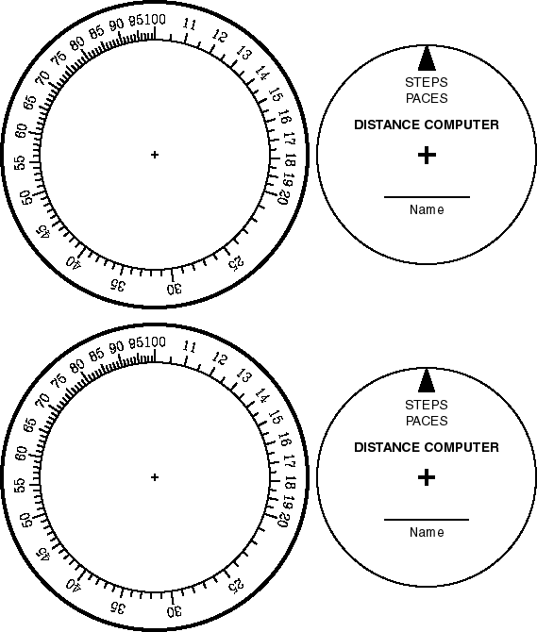

Compass Rose

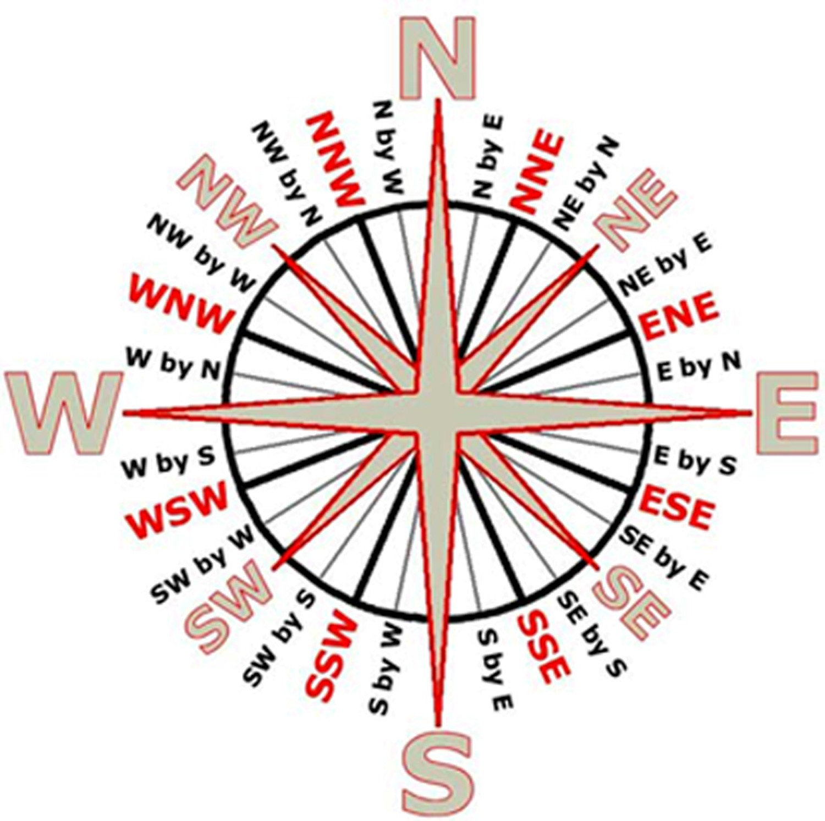

THIS IS LEFT BLANK

2019 Klondike Derby Weigh – In Check List
Please give this form to the Weigh–In station Mayor

Please Check One Box
Webelos |  | Venturer
Scouts |  | Sea Scouts
Senior |  | Explorer

UNIT #

Total #Scouts on Sledge

City/Town _ State _

Patrol Name Patrol Leader

# | Item |  | X
1. | Patrol Leader arm band (must have “PL” on it)
2. | Notebook or clipboard and method to keep score sheet dry
3. | Rain Gear for each member of team (Must be jacket or Poncho)
4. | (1) Pace counter for each team member
5. | (1) Hot cup for each Scout
6. | A complete change of clothes for each Scout
7. | (2) packaged hand warmers per Scout
8. | Patrol Flag
9. | (1) Boy Scout /WEBELOS Scout handbook per sledge
10. | First Aid Kit (from Boy Scout Handbook for Webelos Den/Boy Scout  Troop/Venture Crew/patrol (**See below)
11. | (2) Compasses per sledge
12. | (1) Roll of toilet paper
13. | Trash Bag (for rubbish)
14. | (1 Pair) Cooking gloves or oven mitts
Nuggets scored: (Max. 14) (Subtract 1 nugget for every item missing,
**Subtract 10 nuggets each for First Aid Kit)
Sledge Weight | Total Weight  lbs. | Nuggets scored (max 14) (Subtract 1 for every 5lbs. under 50lbs. Total Weight
 |  | Total Nuggets

THIS IS LEFT BLANK

Service Area Patrol Leader

Unit# City/Town

Total #Scouts on Sledge _Total #Adults Total #Patches_

Patrol Name

Scout Name | Age
1.
2.
3.
4.
5.
6.
7.
Average Age

7 Scouts will be allowed on 1 Sledge, more than 8 need to be on 2 separate Sledges.
NO EXCEPTIONS

Some stations are set-up to hold 7 Scouts, any overage may result in Scout stepping aside for that station.

Please Check One Box
Webelos | 10-11 years of age
Scouts | 11-17 years of age (Average Patrol Age 13.9 or Less)
Senior | 11-17 years of age (Average Patrol Age 14.0 or Greater)
Venturer | 14-21 years of age (Boys and Girls)
Sea Scouts | 14-21 years of age (Boys and Girls)
Explorer | 14-21 years of age (Boys and Girls)

THIS IS LEFT BLANK

Service Area Patrol Leader

Unit# City/Town

Total #Scouts on Sledge _Total #Adults Total #Patches_

Patrol Name

Scout Name | Age
1.
2.
3.
4.
5.
6.
7.
Average Age

7 Scouts will be allowed on 1 Sledge, more than 8 need to be on 2 separate Sledges.
NO EXCEPTIONS

Some stations are set-up to hold 7 Scouts, any overage may result in Scout stepping aside for that station.

Please Check One Box
Webelos | 10-11 years of age
Scouts | 11-17 years of age (Average Patrol Age 13.9 or Less)
Senior | 11-17 years of age (Average Patrol Age 14.0 or Greater)
Venturer | 14-21 years of age (Boys and Girls)
Sea Scouts | 14-21 years of age (Boys and Girls)
Explorer | 14-21 years of age (Boys and Girls)

THIS IS LEFT BLANK

Service Area Patrol Leader

Unit# City/Town

Total #Scouts on Sledge _Total #Adults Total #Patches_

Patrol Name

Scout Name | Age
1.
2.
3.
4.
5.
6.
7.
Average Age

7 Scouts will be allowed on 1 Sledge, more than 8 need to be on 2 separate Sledges.
NO EXCEPTIONS

Some stations are set-up to hold 7 Scouts, any overage may result in Scout stepping aside for that station.

Please Check One Box
Webelos | 10-11 years of age
Scouts | 11-17 years of age (Average Patrol Age 13.9 or Less)
Senior | 11-17 years of age (Average Patrol Age 14.0 or Greater)
Venturer | 14-21 years of age (Boys and Girls)
Sea Scouts | 14-21 years of age (Boys and Girls)
Explorer | 14-21 years of age (Boys and Girls)

THIS IS LEFT BLANK

Please Check One Box

Score Sheet

UNIT #
Total # Scouts on Sledge

Starting at Town #
Webelos |  | Venturer
Scouts |  | Sea Scouts
Senior |  | Explorer

City/Town State

Patrol Name Patrol Leader

Start at X after Weigh-in | Station | Event | Time In | Time  Out | Nuggets  Scored
Boat House | The Outfitters  (Boat House) Field | WEIGH-IN
Scoutcraft Area | 1 | Cheechaku  (Blind Tent Set-Up)
Gaga Pit | 2 | Attu (Mushing)
Health Lodge | 3 | Dead Horse (First Aid)
Archery Range  Webelos Only | 4A | Fort Yukon  (Rifle Competition-BB Guns)
Shotgun Range  Sen/Ven/Sea/Expl Only | 4B | Fort Yukon  (Black Powder Competition)
Rifle Range  Scout Only | 4C | Fort Yukon  (Rifle Competition-22)
Blue Spruce Pine Grove | 5 | Whitehorse  (Log Pull by Pully System)
Scoutcraft Area | 6 | Skagway (Wood Splitting)
Cadre | 7 | Kodiak (Fire Dousing)
Namasket | 8 | Satan’s Landing  (Chasm Crossing)
Mattapoisett | 9 | Sourdough  (Knot Knowledge)
Acooshnet  Webelos/Scout Only | 10A | Crooked Creek  (Milk Box Stacking)
Parade Field  Sen/Ven/Sea/Expl Only | 10B | Rabbit Creek  (Hatchet Throwing)
Pine Grove | 11 | Valley Forge (Cooking)
Tom Cullen Field | 12 | Chil Koot Pass  (Compass Course)
Warming Station | 13 | Kims Games
Trading Post/Dinning Hall | “ | The Great Sledge Race
 |  |  | TOTAL SCORE

THIS IS LEFT BLANK

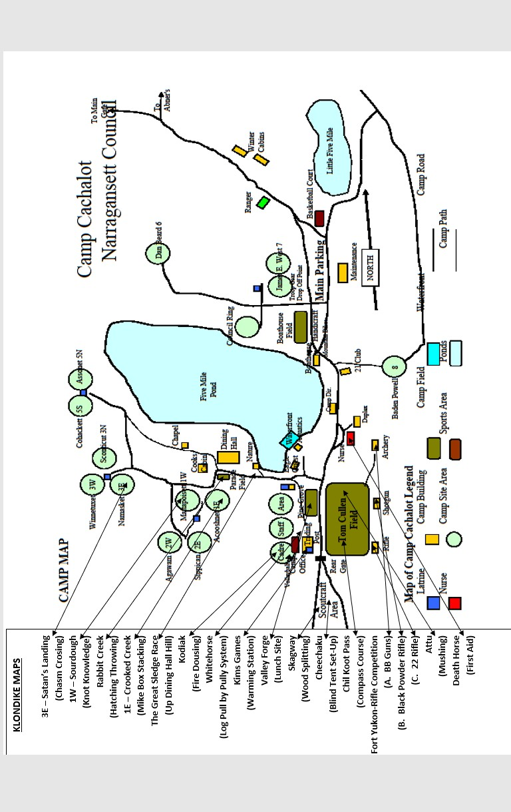

49

