2019 Webelos Overnighter
ITEMS NEEDED
“Mythical Creatures”
Please have your Class A Uniform and/or of course,
you may wear your Mythical style Outfit to dinner.
All Webelos Welcome!
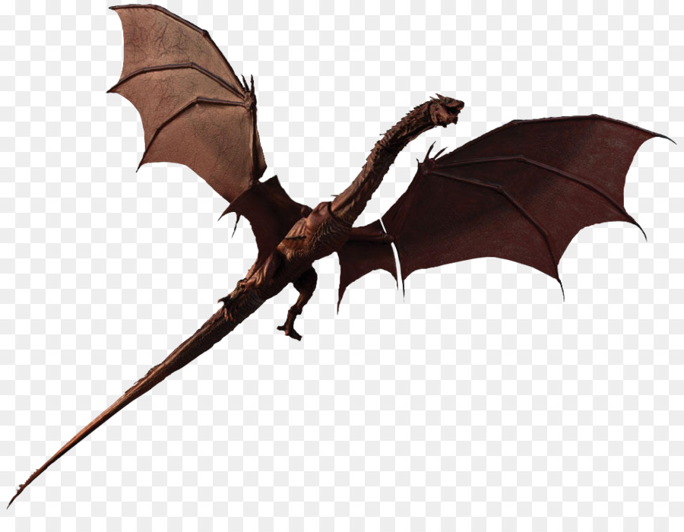

Tent
Tarp/Plastic sheet for under tent to keep you dry
Sleeping Bag, Air Mattress/Blankets
Pillow (it’s OK to bring a pillow)
Flashlight/Camping Lantern
Extra Batteries
Dry clothes, especially socks (tip: Change your clothes before you go to sleep. You will be much warmer because you will not be sleeping in your days sweat.)
Extra Shoes (NO OPEN TOED SHOES AT CAMP!)
Rain Gear (although we have ordered beautiful weather for the day!)
Personal First Aid Kit
Camping Chair
Insect Repellent (Non-Aerosol Only)
Personal Toiletries
Any medication you normally take or need
A Compass
Notepad and pen/pencil
Class A Uniform and/or Mythical style Outfit
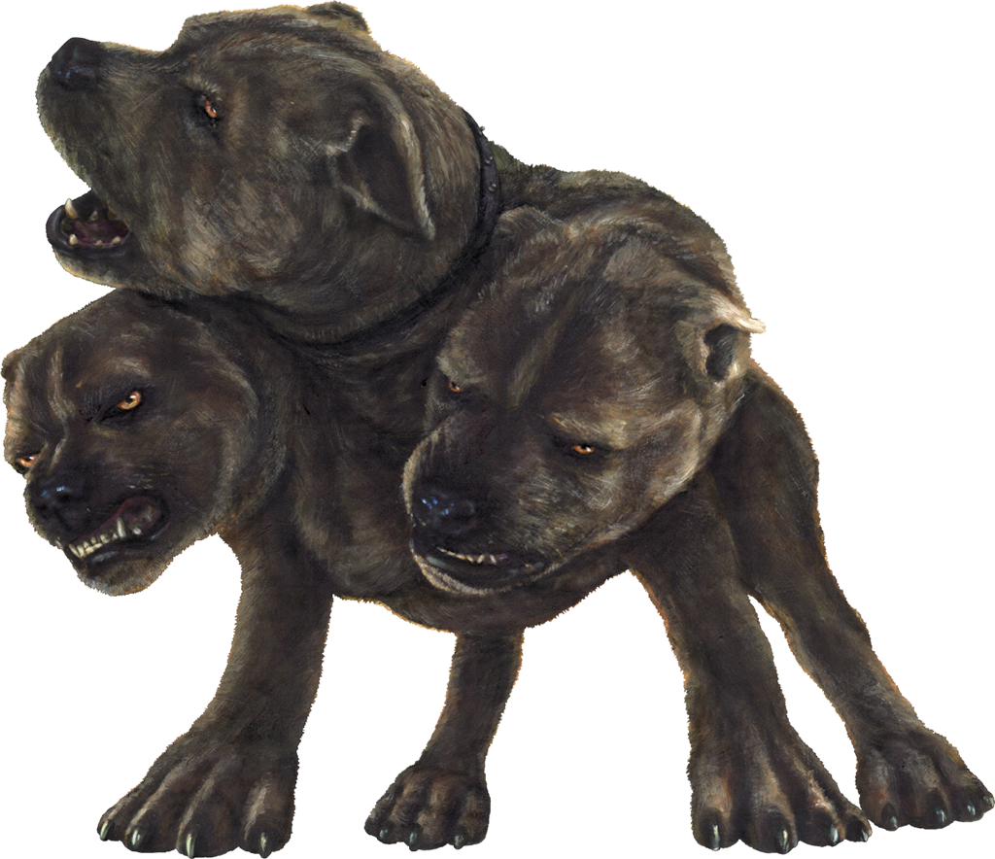
EACH UNIT IS ENCOURAGED TO HAVE A SKIT AND SONG

CONTACT INFORMATION
Patty/Martin Gomm: 401-222-0920 ~ pattygomm.bsa@gmail.com
Flo Stevens: Home: 401-568-0395 ~ Cell: 401-692-6716 ~ newtfla@gmail.com

