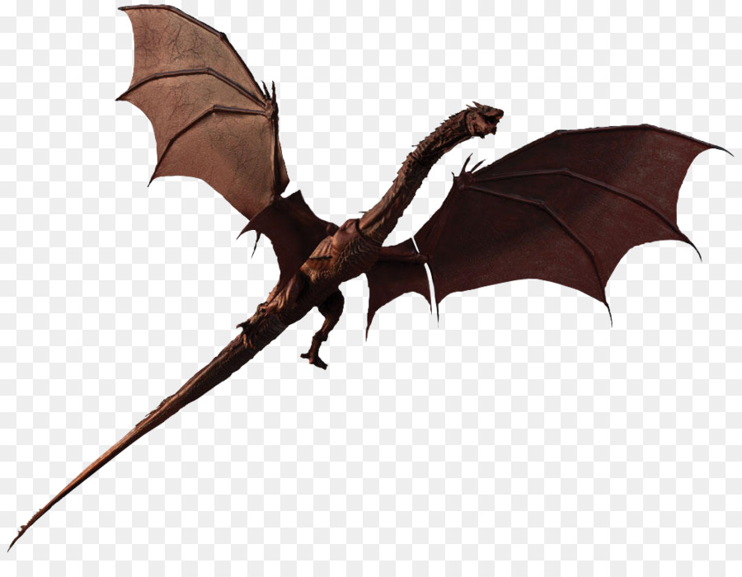
Chuckwagon at Cub World,
Explained!

A Chuckwagon is an event similar to the Boy Scout Klondike. The Cub Scouts pull a wagon to different stations. The wagon can be your rusty old Radio Flyer or your Pack can build a wagon that the pioneers would have loved to take across the plains! They go from station to station, practicing Scout skills and playing games or doing activities.

Some stations are competitions and some are just for fun.The most popular is the Shooting Sports.
Every wagon is guaranteed to participate in both archery and BB. We've give you a set time to be at each one. Lions cannot do archery and BB but they will do something almost as good!

Stations close at 3pm so station leaders can get the awards in on time. Packs then go to the amphitheater to watch a show. They join in performing skits and songs or just sing and laugh while they watch others. The awards are brought out as close to 3:30pm as we can. Awards are read off and you're out of there close to 4pm!

The day will be filled with fun and surprises no matter what the weather is. Chuckwagon happens rain or shine and the Scouts have fun either way. When you arrive in the morning and register, you are given a bag with your patches and some goodies that we've prepared for you. During the day, if you stop by our administration building or see some of our key Leaders, sing or shout out your cheer for them and you'll get some cool themed prizes. It is a day filled with fun and we don’t want you to miss it!

The only problem you may encounter this year is that you may not get to join us. When a good time is had by all, word spreads. We are also advertising more this year. There is a cap of how many Scouts may attend, so register early. If you wait to register until the last minute, we may have reached our maximum numbers and you'll miss out on the fun!

We hope to see you at the Chuckwagon at Cub World. It is Saturday, May 18, 2019 and this year's theme is “Mythical Creatures”. Your Webelos can continue their fun by staying over for our Webelos Overnighter, directly following the Chuckwagon. They will earn advancement while practicing Scout skills and participating in the many surprises that the Leaders have in store! They have an awards ceremony after Sunday's breakfast, before they head for home. Please contact us with any questions that you may have.

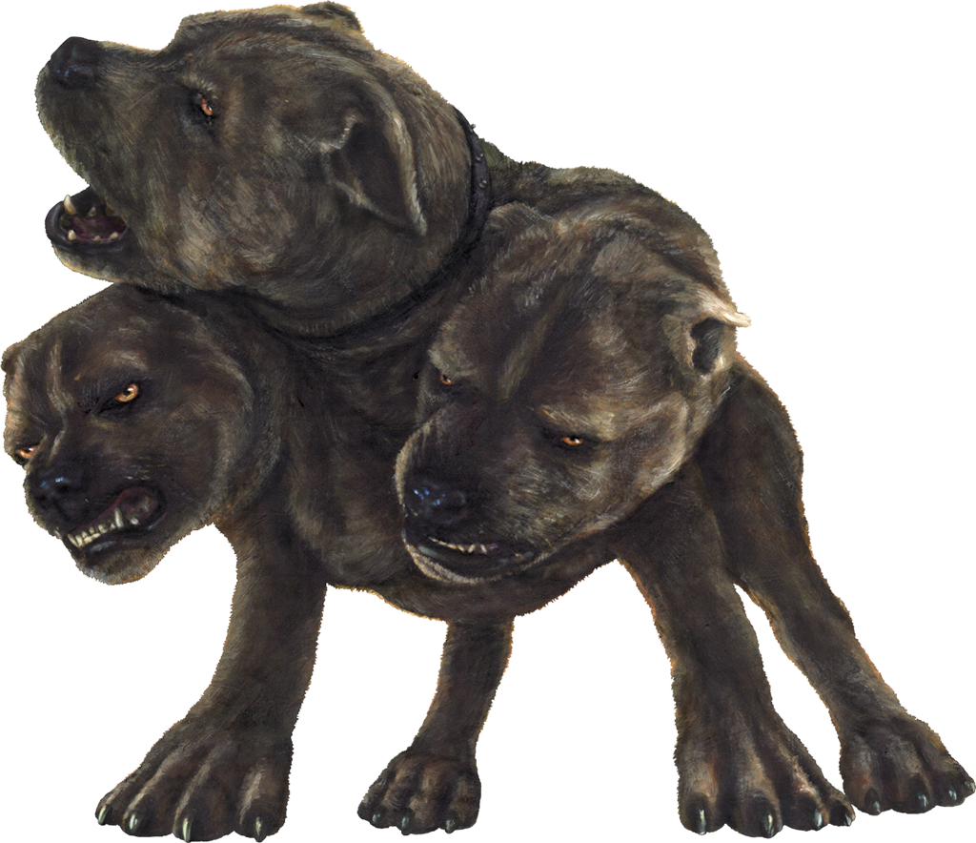
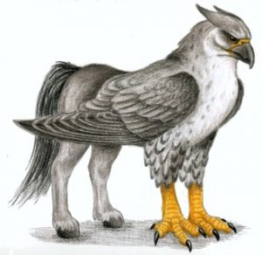
Flo Stevens ~ newtfla@gmail.com
Cell: 401-692-6716 ~ Home: 401-568-0395

