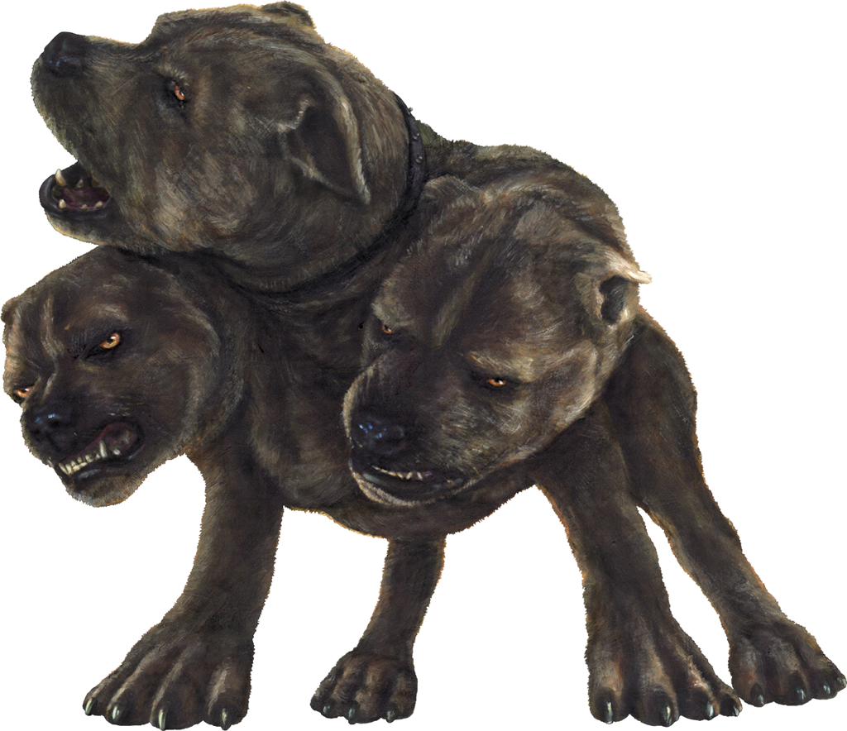
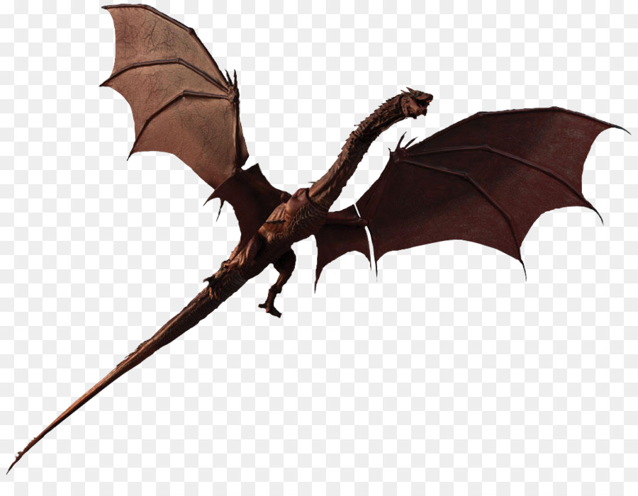
2019 Chuckwagon
“Mythical Creatures”

Station Schedule
 | 9:00 – 10:15am | 10:15 – 11:30am | 12:30 – 1:45pm | 1:45 – 3:00pm
HIGH SEAS | Wagons  101-120 | Wagons  201-220 | Wagons  301-320 | Wagons  401-420
AMPHITHEATER | Wagons  401-420 | Wagons  101-120 | Wagons  201-220 | Wagons  301-320
CASTLE | Wagons  301-320 | Wagons  401-420 | Wagons  101-120 | Wagons  201-220
WEBELOS WOODS | Wagons  201-220 | Wagons  301-320 | Wagons  401-420 | Wagons  101-120
 | Wagons 501-520 You may go to any area, including the “Lions Shooting Sports Area” at any time between 9:00-11:30am and 12:30-3:00pm.
All Wagons must remain in their designated area. This is the only way that everyone gets a chance to enjoy all the activities!

