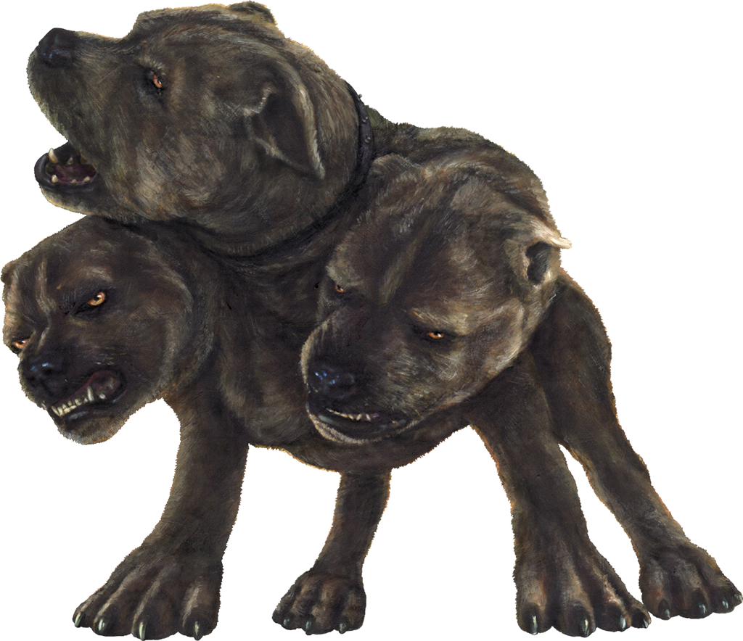
WEBELOS
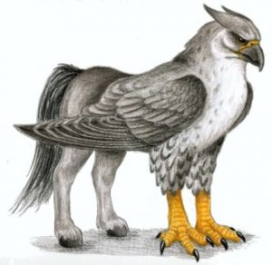
OVERNIGHTER
Saturday, May 18 - 19, 2019
This will immediately follow Chuckwagon, beginning at 4pm. Earn the Webelos Required Adventures “Duty to God” and the Elective Adventure “Adventures in Science”

“Mythical Creatures”

All WEBELOS Welcome!

Cost will be $60.00 for the Parent and Scout Team.
(This includes the $30 Team fee for the Chuckwagon)
Additional Webelos $30 (including the $15 Individual fee)
A Parent/adult is required to attend.

Join us at Cub World for an evening of food, fun, adventure,
campfire and many Webelos centered activities! Dinner and a continental breakfast is included.
For Dinner wear a Mythical Creature themed outfit or your Class A Uniform.
Bring your tent!
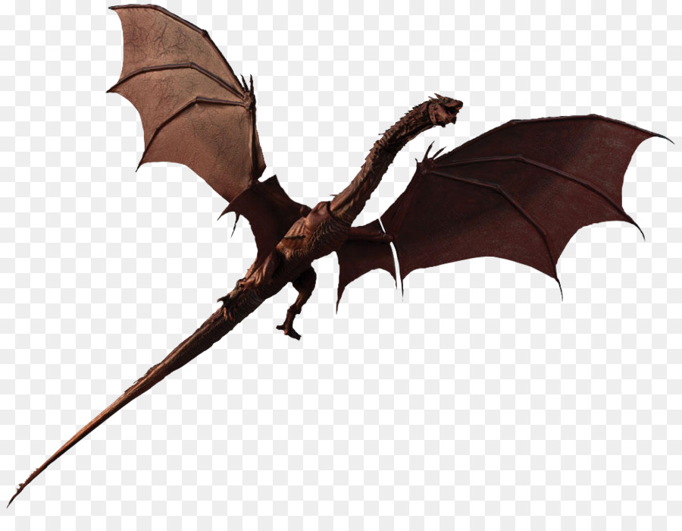
Think of a song or skit for the campfire!
Refer to the “Items Needed” sheet for a packing list.
Please register early. There are a limited number of spaces.

Contacts: Flo Stevens: 401-568-0395 ~ Cell: 401-692-6716 ~ newtfla@gmail.com
Patty and Martin Gomm: 401-222-0920 ~ pgomm@courts.ri.gov

